**EEG DATA ANALISYS THROUGH EEGLAB**

**To Download EEGLAB**

Download eeglab <https://sccn.ucsd.edu/eeglab/download.php>

Unzip folder inside your MATLAB/toolbox folder.

Open Matlab and on command window write:

*addpath('/YOURPATHTOMATLAB/toolbox/eeglab2020_0')*

Then write:

*eeglab*

to open the GUI.

**A bit of theory:**

Epoching: EEG epoching is a procedure in which specific time-windows are extracted from the continuous EEG signal.

These time windows are called “epochs”, and usually are time-locked with respect an event e.g. a visual stimulus.

If your EEG data are in a matrix [channel x time] where time is the complete continuous EEG signal, after the epoching procedure you should have a matrix [channel x time x epochs] where time is the time length of each epoch, and epochs is the number of segments you extracted from continuous EEG signal.

If you want to extract epochs from your signal, you should know what are the segments of interest to be analyzed, for instance, a specific stimulus.

Electroencephalogram (EEG) data are typically contaminated with artifacts (e.g., by eye movements).

The effect of artifacts can be attenuated for example with the Independent component analysis (ICA) that separates EEG data into neural activity and artifact; once identified, artifactual components can be deleted from the data.

**ICA (Independent Component Analysis):**

Signal processing method to separate independent sources linearly mixed in several sensors. We use it because different source points of EEG signals produce signals that are then captured by different electrodes and we need to separate the information obtained.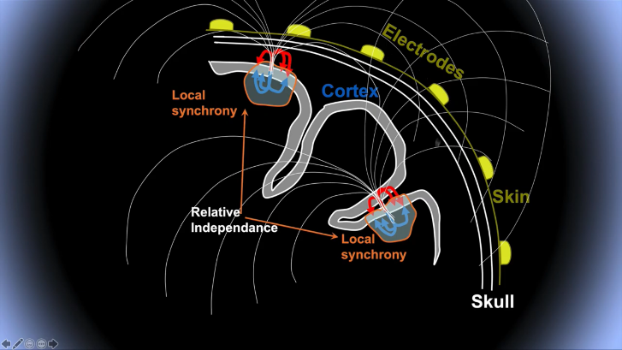

It recovers the original sources by multiplying the data X by an unmixing matrix W:

U=WX

X: data (channels x time)

U: ICA source activities (component x time)

W: ICA unmixing matrix (components x channels)

Example of ICA applied to EEG:

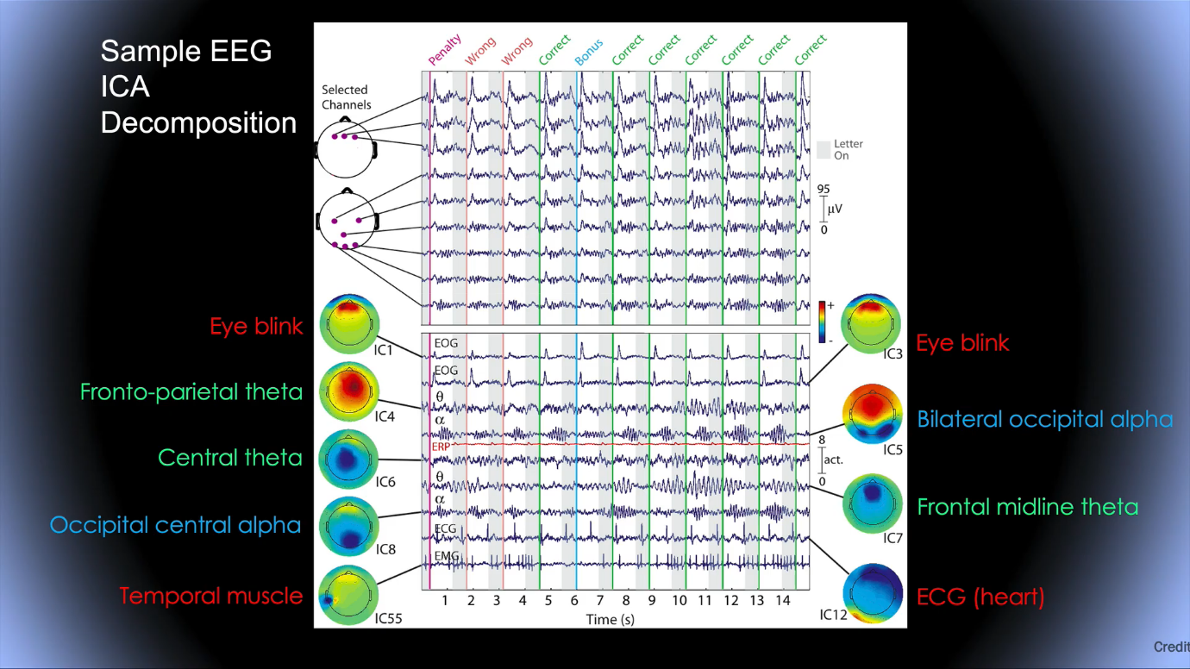

**To analyze data (**Notice: parts in italic are the buttons to click)

IMPORT INTO EEGLAB

*file -> load existing data* : load your dataset

*plot -> channel data (scroll)* : see your dataset

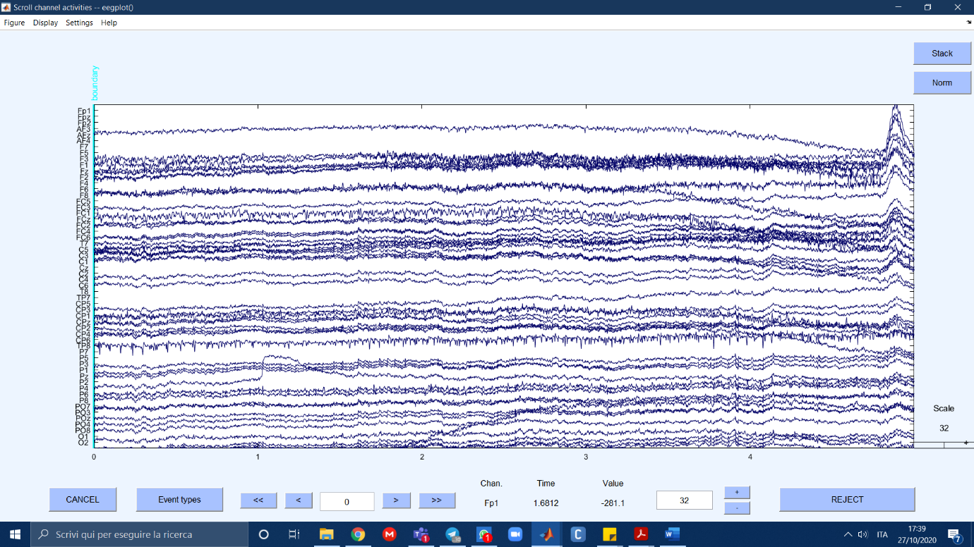

IMPORT CHANNEL LOCATIONS

*Edit -> import channel locations -> ok*

->Plot 2d

->Plot 3d

DOWN-SAMPLE

*Tools -> change sampling rate* -> write your rate (here 250)

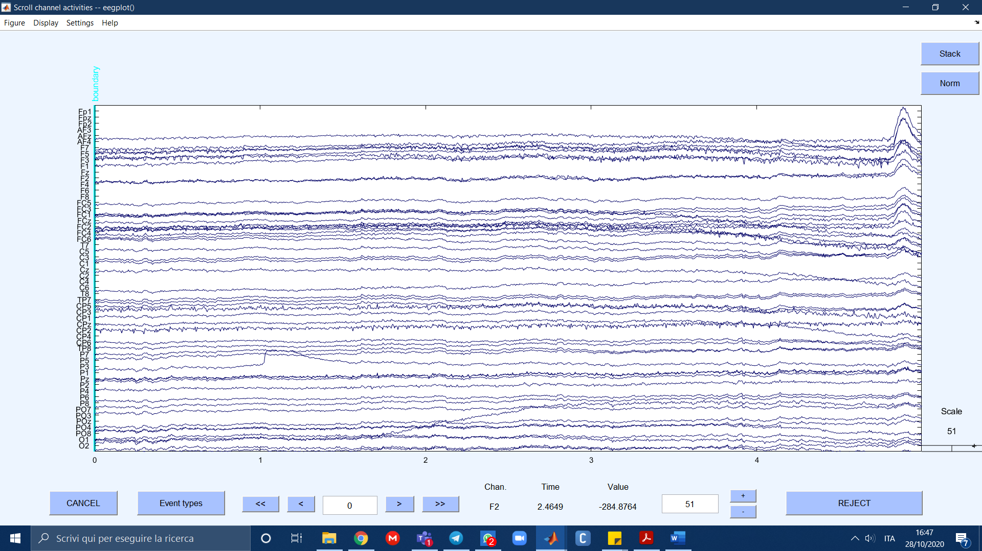

FILTER THE DATA

*Tools -> filter the data -> basic FIR filter* -> set high and low values (here: 1-80)

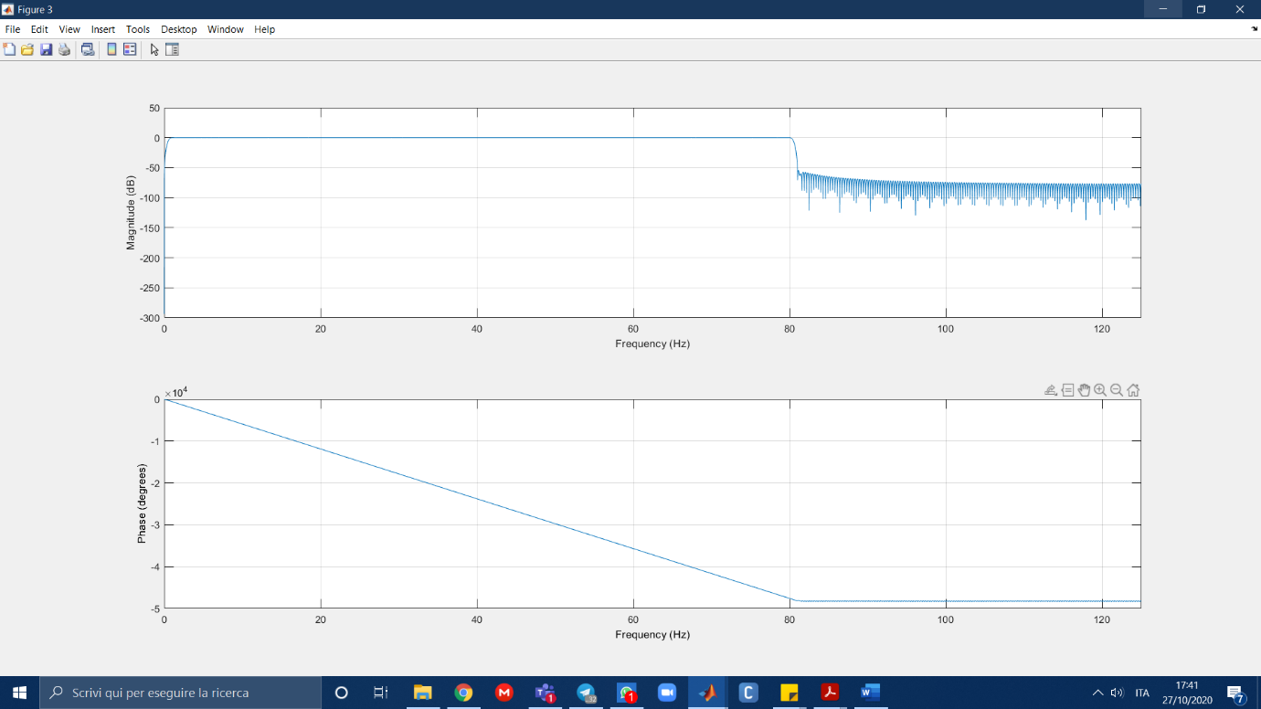

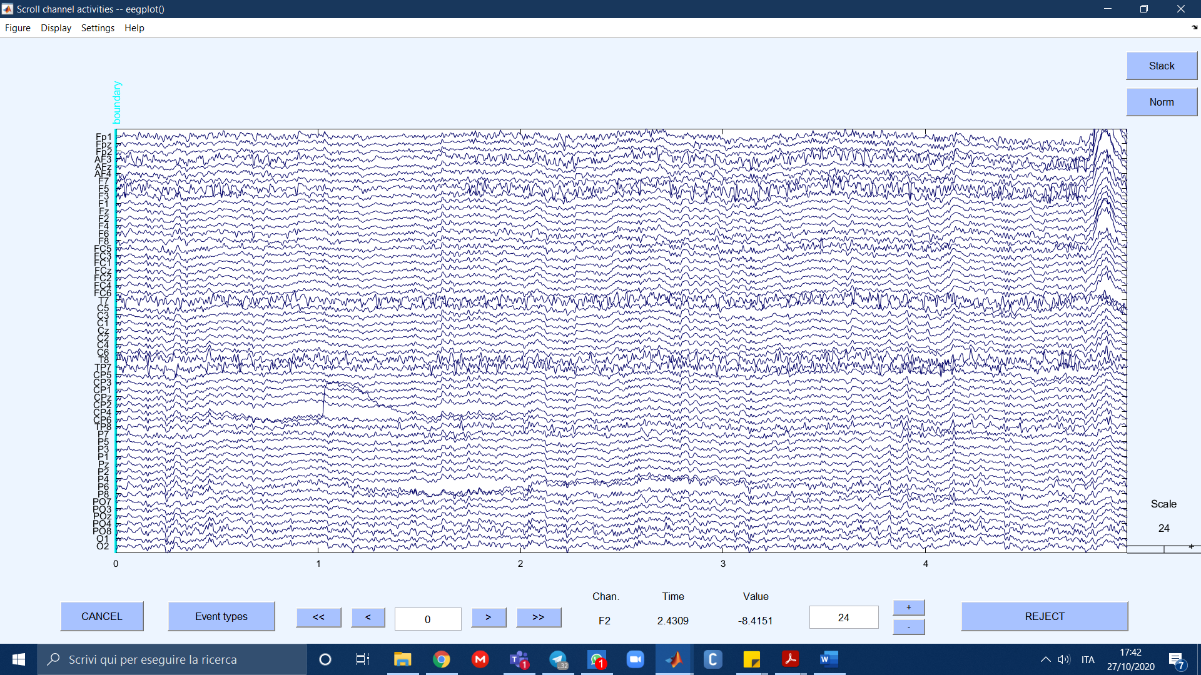

*Tools -> filter the data -> notch filter* -> set values around your desired value (here: 45-55)

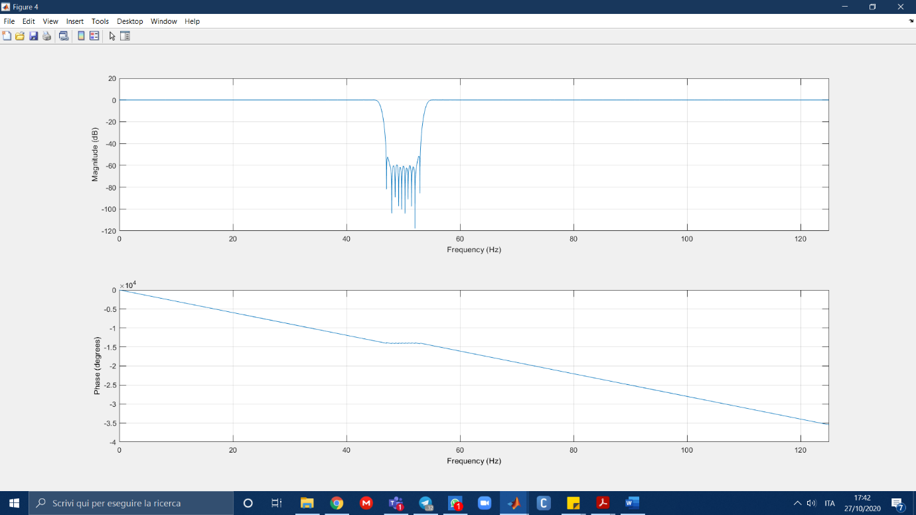

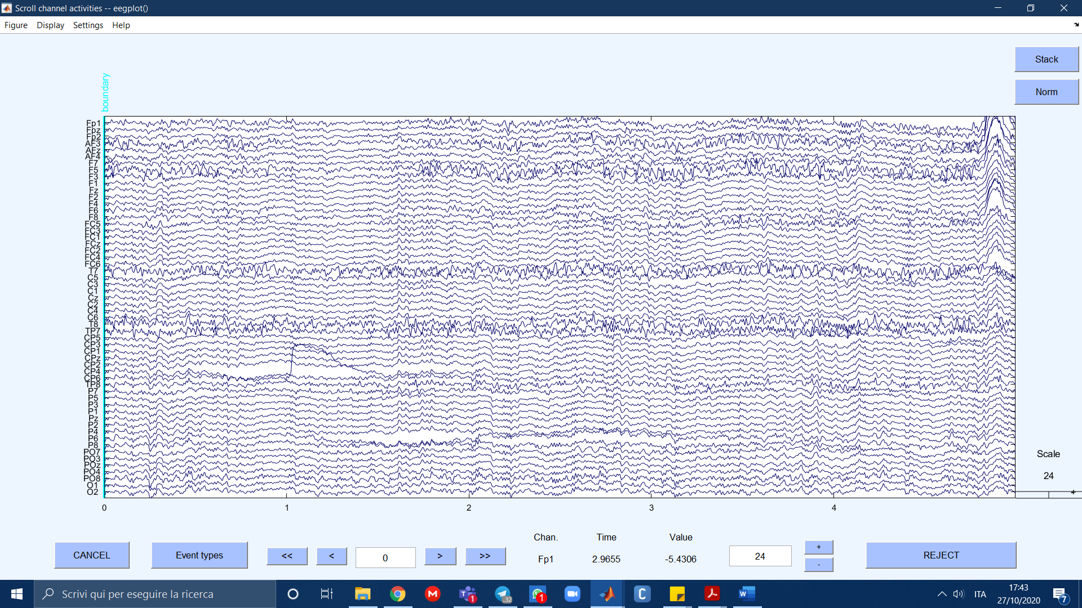

EXTRACT EPOCHS

*Tools -> extract epochs*

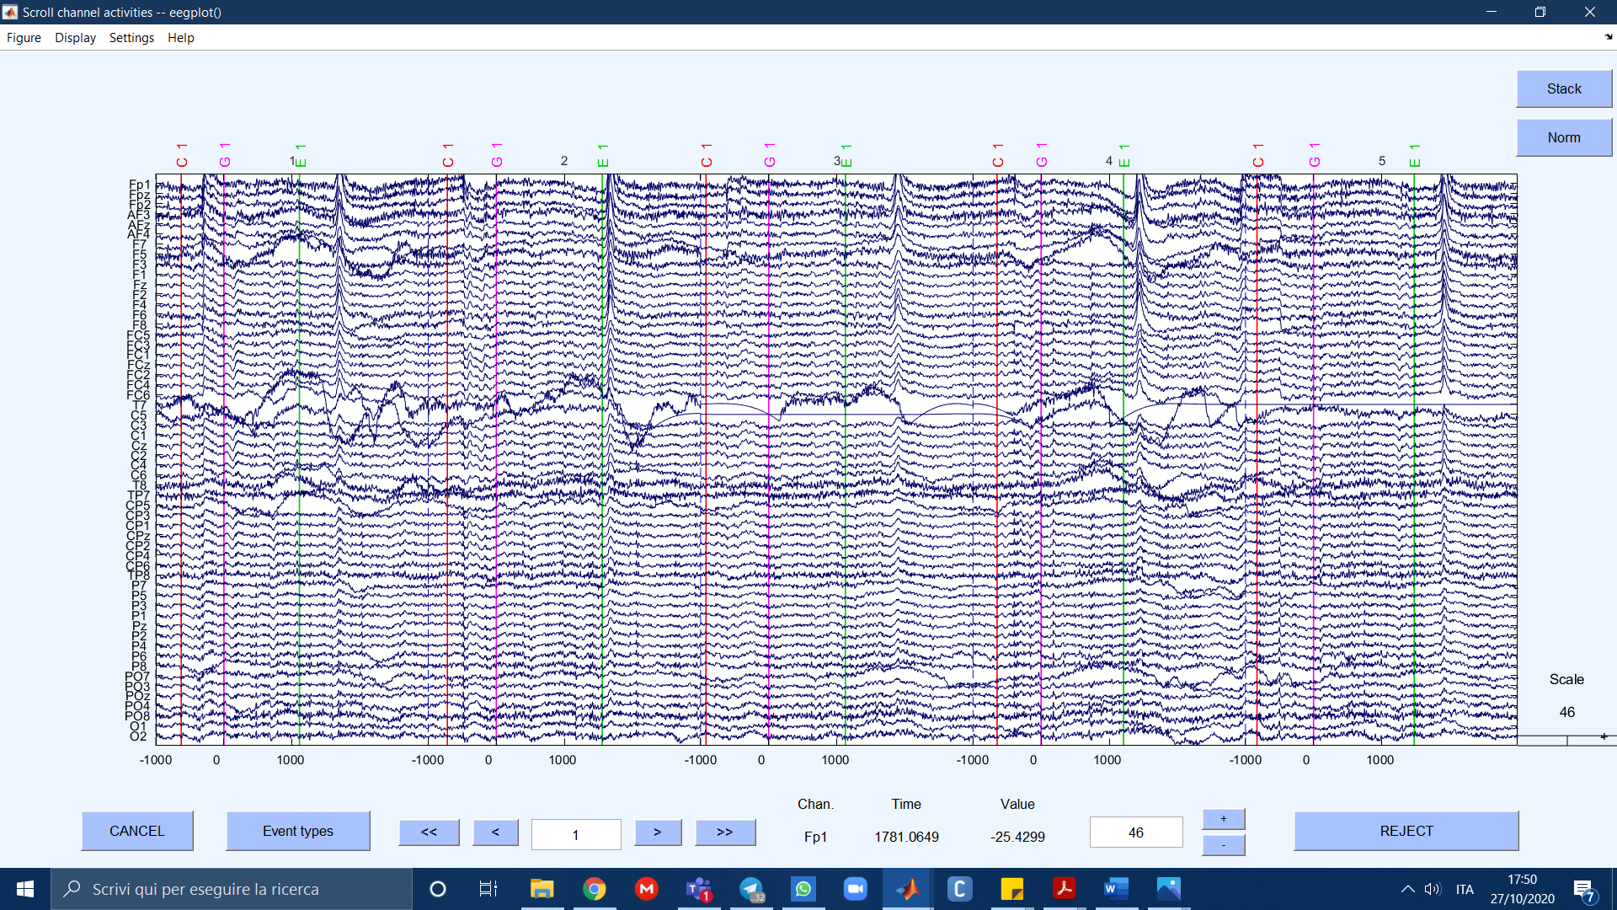

Data set brief description: The events are of three types:

1. C: see red target.
2. G: target becomes pink: go towards it with your arm+ee.
3. E: movement finishes.

We try this multiple times then make an average of the data. Synchronization is important since we can link EEG data to real events. Data is like a matrix channels x epochs. You can remove either an entire row or an entire column, not pieces or u can’t do the analysis.

EXAMINING RAW DATA (already done)

*Tools -> Reject continuous data by eye*

*plot -> channel data (scroll)*

REMOVING BAD CHANNNELS (check chapterExamples of bad channels/epochs):

*Plot -> channel spectra and map -> ok* -> write 100 in the percent data to sample -> *ok* -> click on out of range traces: it gives you the number of the unwanted channels

*Plot -> channel properties* -> write the channel indexes you want to check

*Tools -> automatic channel rejection*: check with probability and kurtosis

+ clean_rawdata plugin

*Edit -> select data ->* select the unwanted channels and check box!

Here: T7, C5 create big problems in the first data, we removed them.

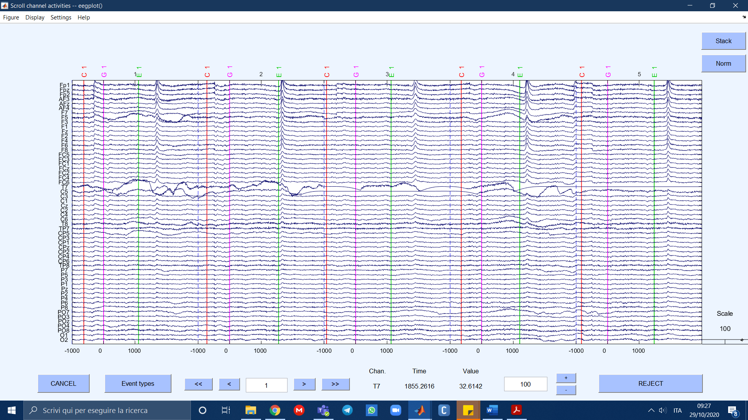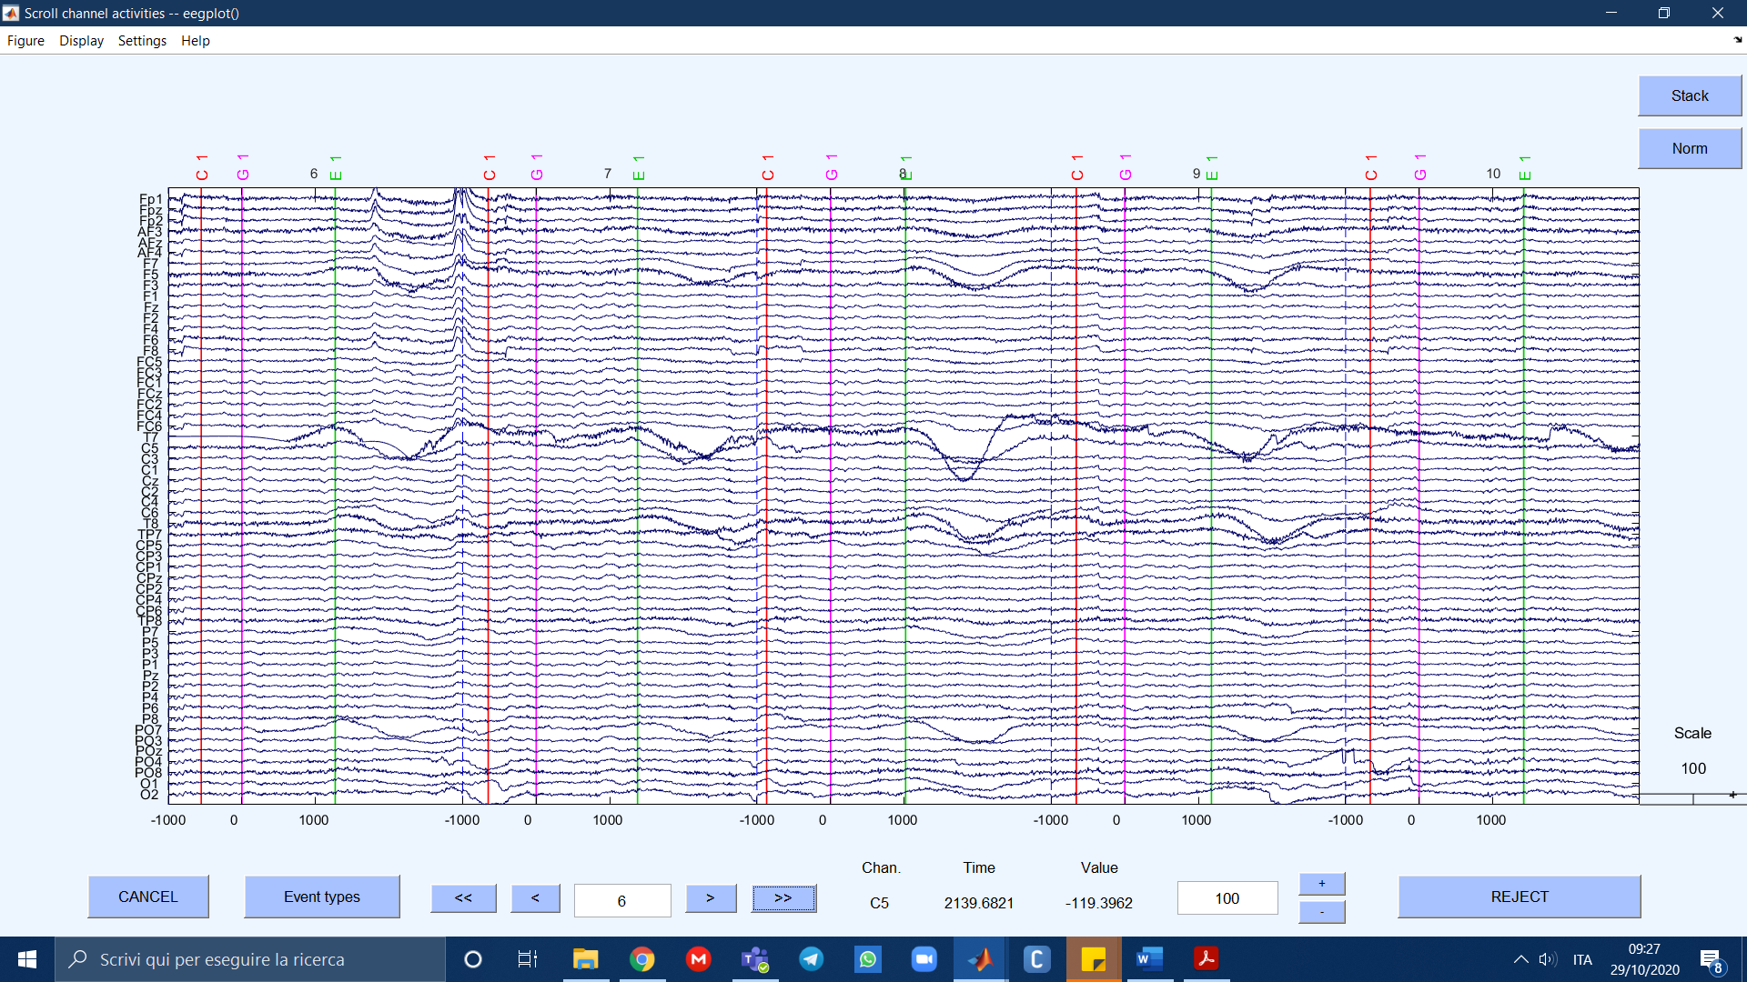

From spectra plotting, instead, we didn’t notice many anomalies:

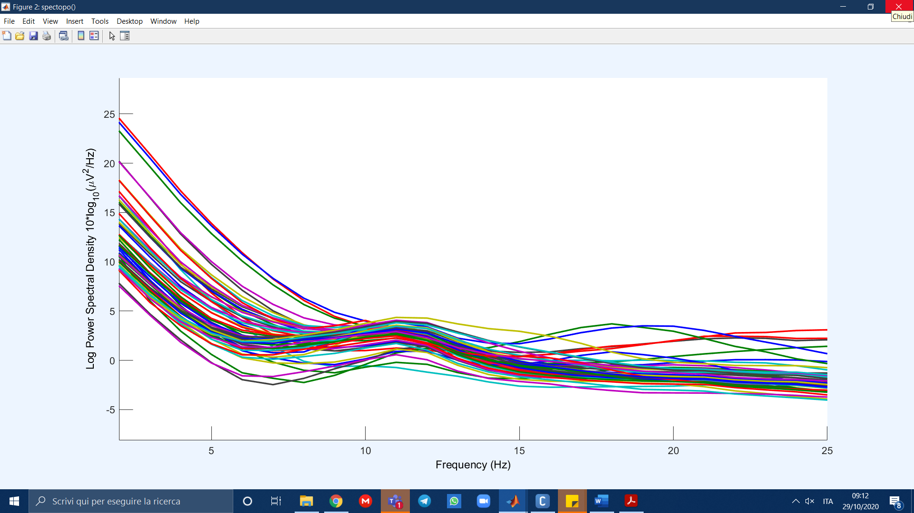

REMOVING BAD EPOCHS

Don’t remove eye blinks: they will be removed by ICA. Remove high frequency epochs that don’t make sense. Remove electrode artifacts.

*Plot -> Channel data scroll -> Settings -> Time range to display ->* set a higher time range to have a better view *-> stack -> norm* -> the channels that don’t match with the others are outliers

Here: we removed 37 epochs: the ones with removed elecrodes, the ones with high frequency muscular data,…

RUN ICA

*Edit -> Channel locations -> Use MNI coordinates for the BEM Dipfit model*

*Tools -> ICA decompose data by ICA* (it takes a while)

Plot -> Component maps -> 2D

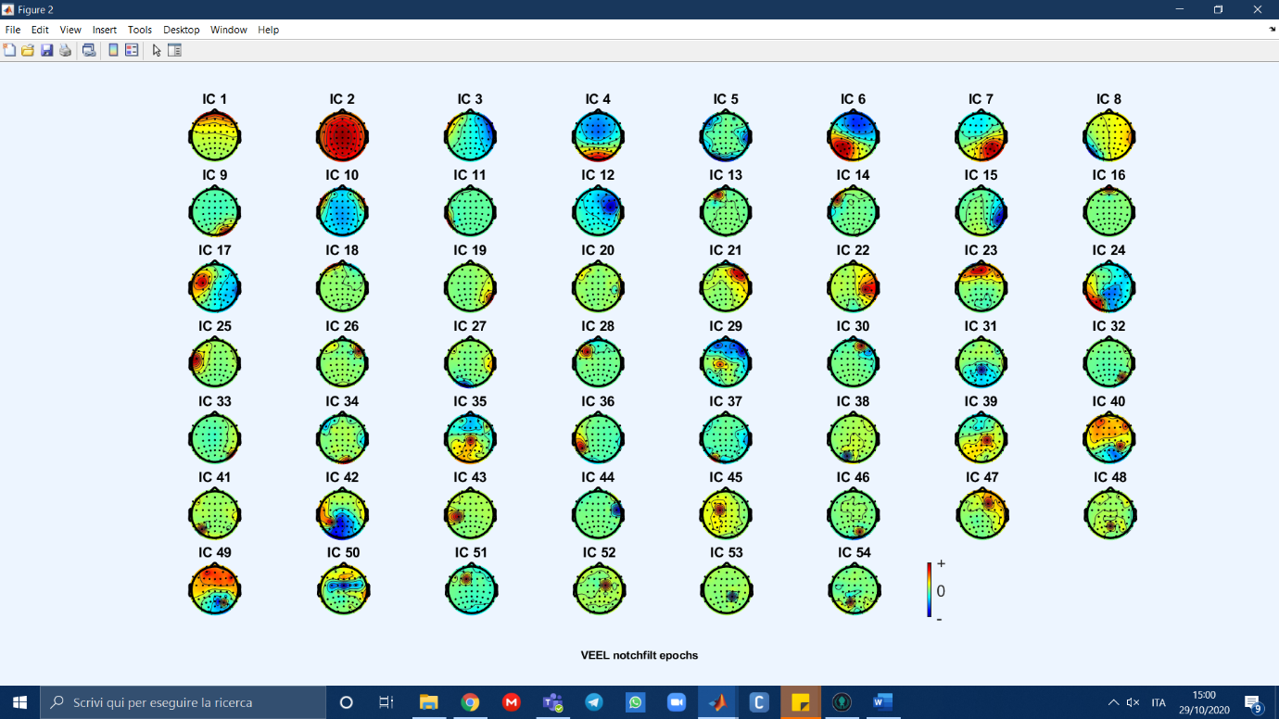

**Examples of bad channels/epochs:**

